Strongs Dictionary Translations

# ER Diagram

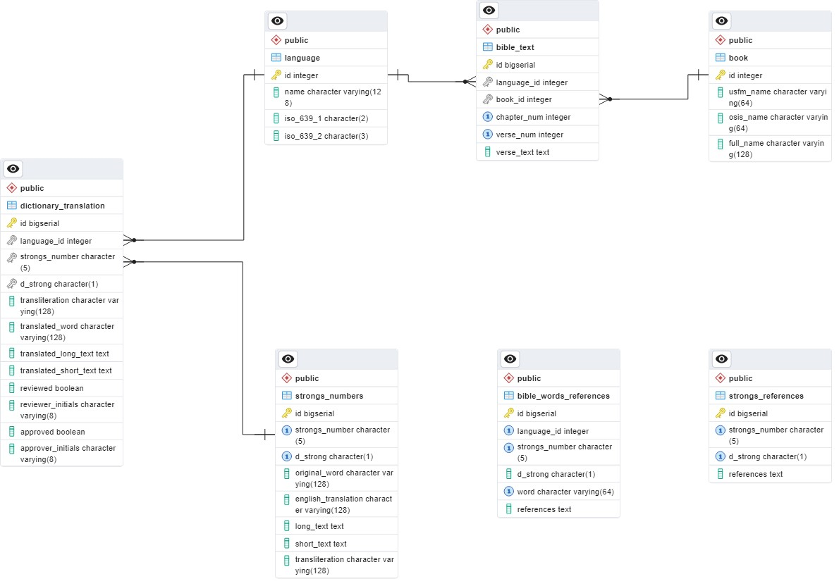

# Tables

## strongs_numbers

This table is populated using the information in the untranslated [spreadsheets](https://docs.google.com/document/d/1TR0CSZ124SwnWj28F4us4XAFU1CQtrb9/preview) prepared by Dr. David Instone-Brewer.

The following image shows how the different spreadsheet cells are mapped to the table’s fields.

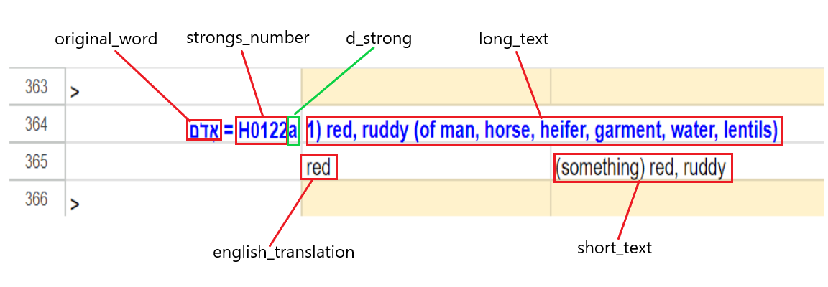

## dictionary_translation

After translating the spreadsheet via Google Translate, all cells in the second column are replaced with their translation to the target language.

The following image shows how the cells of the translated spreadsheet are mapped to the table’s fields.

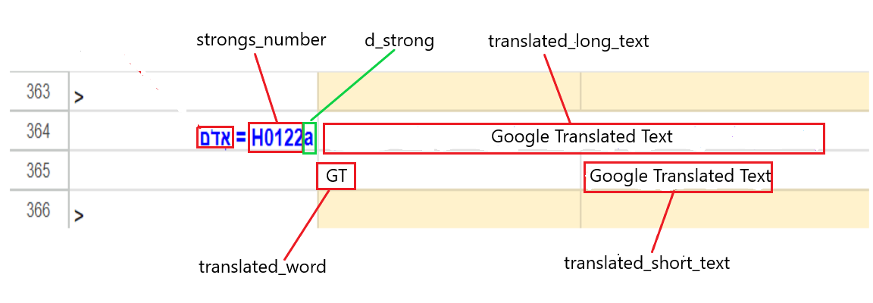

This table also have fields to be populated after the translation has been reviewed and approved.

## language

Populated with a list of languages and their codes as defined by ISO 639-1 and 639-2

## strongs_references

Populated with all verse references associated with a specific Strong’s number. References are stored as a comma separated list. E.g. Gen 41:36, Lev 25:4, Psa 74:7, Psa 147:8

## Book

Populated with a list of the books of the bible and their OSIS and USFM abbreviations

# Appendix – Table Definitions

|  |
| --- |
| -- This script was generated by the ERD tool in pgAdmin 4.  -- Please log an issue at https://redmine.postgresql.org/projects/pgadmin4/issues/new if you find any bugs, including reproduction steps.  BEGIN;  DROP TABLE IF EXISTS public.strongs_numbers CASCADE;  DROP TABLE IF EXISTS public.book CASCADE;  DROP TABLE IF EXISTS public."bible_words_references" CASCADE;  DROP TABLE IF EXISTS public."bible_text";  DROP TABLE IF EXISTS public."dictionary_translation";  DROP TABLE IF EXISTS public."language";  DROP TABLE IF EXISTS public."strongs_references";  CREATE TABLE IF NOT EXISTS public.bible_text  (  id bigserial NOT NULL,  language_id integer NOT NULL,  book_id integer NOT NULL,  chapter_num integer NOT NULL,  verse_num integer NOT NULL,  verse_text text COLLATE pg_catalog."default",  CONSTRAINT bible_text_pkey PRIMARY KEY (id),  CONSTRAINT bible_text_book_id_chapter_num_verse_num_key UNIQUE (book_id, chapter_num, verse_num)  );  CREATE TABLE IF NOT EXISTS public.strongs_numbers  (  id bigserial NOT NULL,  strongs_number character(5) COLLATE pg_catalog."default" NOT NULL,  d_strong character(1) COLLATE pg_catalog."default",  original_word character varying(128) COLLATE pg_catalog."default" NOT NULL,  english_translation character varying(128) COLLATE pg_catalog."default" NOT NULL,  long_text text COLLATE pg_catalog."default",  short_text text COLLATE pg_catalog."default",  transliteration character varying(128) COLLATE pg_catalog."default",  CONSTRAINT "StrongsNumbers_pkey" PRIMARY KEY (id),  CONSTRAINT strong_numbers_unique UNIQUE (strongs_number, d_strong)  );  CREATE TABLE IF NOT EXISTS public.bible_words_references  (  id bigserial NOT NULL,  language_id integer NOT NULL,  strongs_number character(5) NOT NULL,  d_strong character(1),  word character varying(64) COLLATE pg_catalog."default" NOT NULL,  "references" text,  CONSTRAINT bible_words_references_pkey PRIMARY KEY (id),  CONSTRAINT bible_words_references_augmented_strong UNIQUE (language_id, strongs_number, word)  );  CREATE TABLE IF NOT EXISTS public.book  (  id integer NOT NULL,  usfm_name character varying(64) COLLATE pg_catalog."default" NOT NULL,  osis_name character varying(64) COLLATE pg_catalog."default",  full_name character varying(128) COLLATE pg_catalog."default",  CONSTRAINT book_pkey PRIMARY KEY (id)  );  CREATE TABLE IF NOT EXISTS public.dictionary_translation  (  id bigserial NOT NULL,  language_id integer NOT NULL,  strongs_number character(5) NOT NULL,  d_strong character(1),  transliteration character varying(128),  translated_word character varying(128),  translated_long_text text,  translated_short_text text,  reviewed boolean DEFAULT FALSE,  reviewer_initials character varying(8),  approved boolean DEFAULT FALSE,  approver_initials character varying(8),  PRIMARY KEY (id)  );  CREATE TABLE IF NOT EXISTS public.language  (  id integer NOT NULL,  name character varying(128),  iso_639_1 character(2) NOT NULL,  iso_639_2 character(3) NOT NULL,  PRIMARY KEY (id)  );  CREATE TABLE IF NOT EXISTS public.strongs_references  (  id bigserial NOT NULL,  strongs_number character(5) COLLATE pg_catalog."default" NOT NULL,  d_strong character(1) COLLATE pg_catalog."default",  "references" text COLLATE pg_catalog."default" NOT NULL,  CONSTRAINT "Strongs_references_pkey" PRIMARY KEY (id),  CONSTRAINT strongs_references_augmented_strong UNIQUE (strongs_number, d_strong)  );  ALTER TABLE IF EXISTS public.bible_text  ADD FOREIGN KEY (language_id)  REFERENCES public.language (id) MATCH SIMPLE  ON UPDATE NO ACTION  ON DELETE NO ACTION  NOT VALID;  ALTER TABLE IF EXISTS public.bible_text  ADD FOREIGN KEY (book_id)  REFERENCES public.book (id) MATCH SIMPLE  ON UPDATE NO ACTION  ON DELETE NO ACTION  NOT VALID;  ALTER TABLE IF EXISTS public.dictionary_translation  ADD FOREIGN KEY (language_id)  REFERENCES public.language (id) MATCH SIMPLE  ON UPDATE NO ACTION  ON DELETE NO ACTION  NOT VALID;  ALTER TABLE IF EXISTS public.dictionary_translation  ADD FOREIGN KEY (strongs_number, d_strong)  REFERENCES public.strongs_numbers (strongs_number, d_strong) MATCH SIMPLE  ON UPDATE NO ACTION  ON DELETE NO ACTION  NOT VALID;  END; |